每个单词最长流程：默写10边 + 造句2次 + ~~听力2边~~。

**——————————TO DO———————————**

**——————————DOING———————————**

**———————First Stage(默写5+5遍)————————**

▲ **yummy** [ˈjʌmi] adj. 美味的，令人垂涎的

⟐ This cake is so yummy; I can't stop eating it.

⟐ The restaurant serves a variety of yummy dishes that satisfy all taste buds.

▲ **brutal** [ˈbruːt(ə)l] adj. 残酷的，野蛮的

⟐ The movie depicted the brutal reality of war.

⟐ He faced a brutal attack from his opponents during the debate.

▲ **stifle** [ˈstaɪf(ə)l] v. 压制，抑制

⟐ The government tried to stifle the protests by imposing strict curfews.

⟐ She could barely stifle a laugh during the serious meeting. 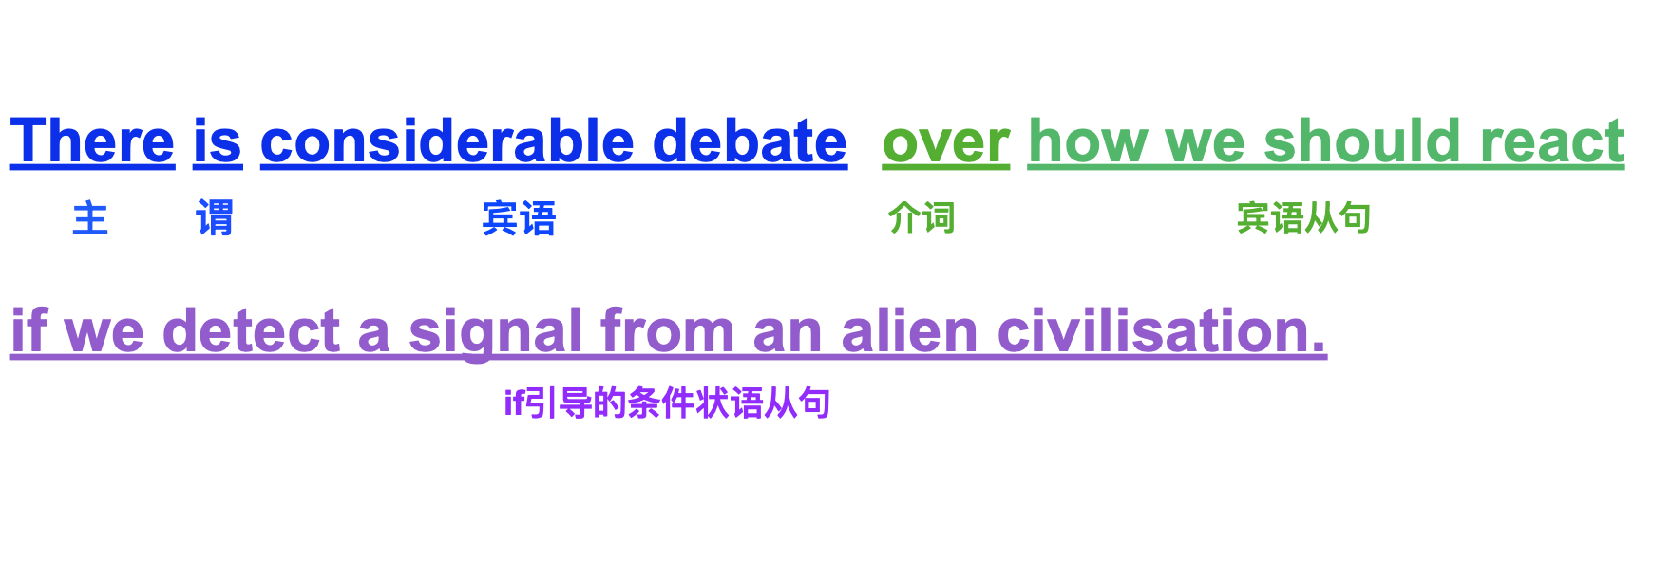

▲ **ginger** [ˈdʒɪndʒər] n. 姜

⟐ I added some fresh ginger to the soup for extra flavor.

⟐ Ginger tea is often consumed to help soothe an upset stomach.

▲ **deduct** [dɪˈdʌkt] v. 扣除

⟐ They will deduct the fees directly from your bank account.

⟐ Remember to deduct your business expenses on your tax return.

▲ **pasture** [ˈpæstʃər] n. 牧场

⟐ The cows are grazing in the open pasture.

⟐ He owns a large pasture where he raises sheep and horses.

▲ **fallible** [ˈfæləb(ə)l] adj. 易错的

⟐ Humans are fallible, so mistakes are a natural part of life.

⟐ The system is fallible and needs regular checks to maintain accuracy.

▲ **envelope** [ˈenvəloʊp] n. 信封

⟐ She sealed the letter and put it in an envelope.

⟐ The invitation came in a fancy envelope with gold lining.

▲ **annual inspection** n. 年检

⟐ The factory undergoes an annual inspection to ensure it meets safety standards.

⟐ Don't forget to schedule your car for its annual inspection.

▲ **abide** [əˈbaɪd] v. 遵守

⟐ You must abide by the rules of the game to play fairly.

⟐ He chose to abide by the terms of the agreement despite the challenges.

▲ **condemn** [kənˈdem] v. 谴责

⟐ The international community condemned the acts of violence.

⟐ He was quickly condemned for his reckless comments.

▲ **versus** [ˈvɜːrsəs] prep. （比赛或诉讼中）以……为对手，与……竞争；与……相对，与……相比

⟐ Tonight's game is the champions versus the new team.

⟐ The case of the people versus the corrupt official will be heard next week.

▲ **enclose** [ɪnˈkloʊz] v. 围绕

⟐ Please enclose a copy of your receipt with the returned merchandise.

⟐ The letter was enclosed in a brightly colored envelope.

▲ **undone** [ʌnˈdʌn] adj. 未完成的；松开的

⟐ She left her shoelaces undone and tripped over them.

⟐ The project was left undone due to lack of funds.

▲ **evident** [ˈevɪdənt] adj. 明显的

⟐ It was evident from his expression that he was upset.

⟐ The benefits of the new policy are evident to everyone.

▲ **debilitate** [dɪˈbɪlɪteɪt] v. 使虚弱；削弱

⟐ The disease will debilitate him for several weeks.

⟐ The harsh winter weather can debilitate even the strongest plants.

▲ **facilitate** [fəˈsɪlɪteɪt] v. 促进；使便利

⟐ The new software will facilitate project management.

⟐ Good communication can facilitate better understanding between teams.

▲ **incur** [ɪnˈkɜːr] v. 招致；遭受

⟐ He incurred heavy debts during his time in college.

⟐ If you cancel now, you will incur a fee.

⟐ He incurred a ticket because his overspeed driving.

▲ **dispute** [dɪˈspjuːt] n. 争论；纠纷

⟐ The two companies are in a legal dispute over the contract.

⟐ There was a dispute among the team members about the best approach to the project.

⟐ Both sides in the dispute have agreed to go to the arbitration.

▲ **leftover** [ˈleftoʊvər] n. 剩余物；残留物

⟐ We always have leftovers after Thanksgiving dinner.

⟐ She packed the leftovers from last night's dinner for lunch.

⟐ The leftovers should be kept in refrigerator.

▲ **rigorous** [ˈrɪɡərəs] adj. 严格的；严厉的

⟐ The training program is very rigorous.

⟐ The project went through a rigorous review process before approval.

⟐ The father is a very rigorous man to his children.

**——————Second Stage（1~2个造句）—————**

**———————Third Stage（听力2遍）———————**

**———————Fouth Stage（发头条）———————**